User Interface : The point from where user interacts with application

Character Based / Graphical Based

Console Applications > Gives you CUI

Graphical Intarface

Windows Applications/ Web Applications

Console / Windows Applications are stand alone , eg. MS Word.

Web Applications can be accessed from anywhere.. How do we access them , using Browser

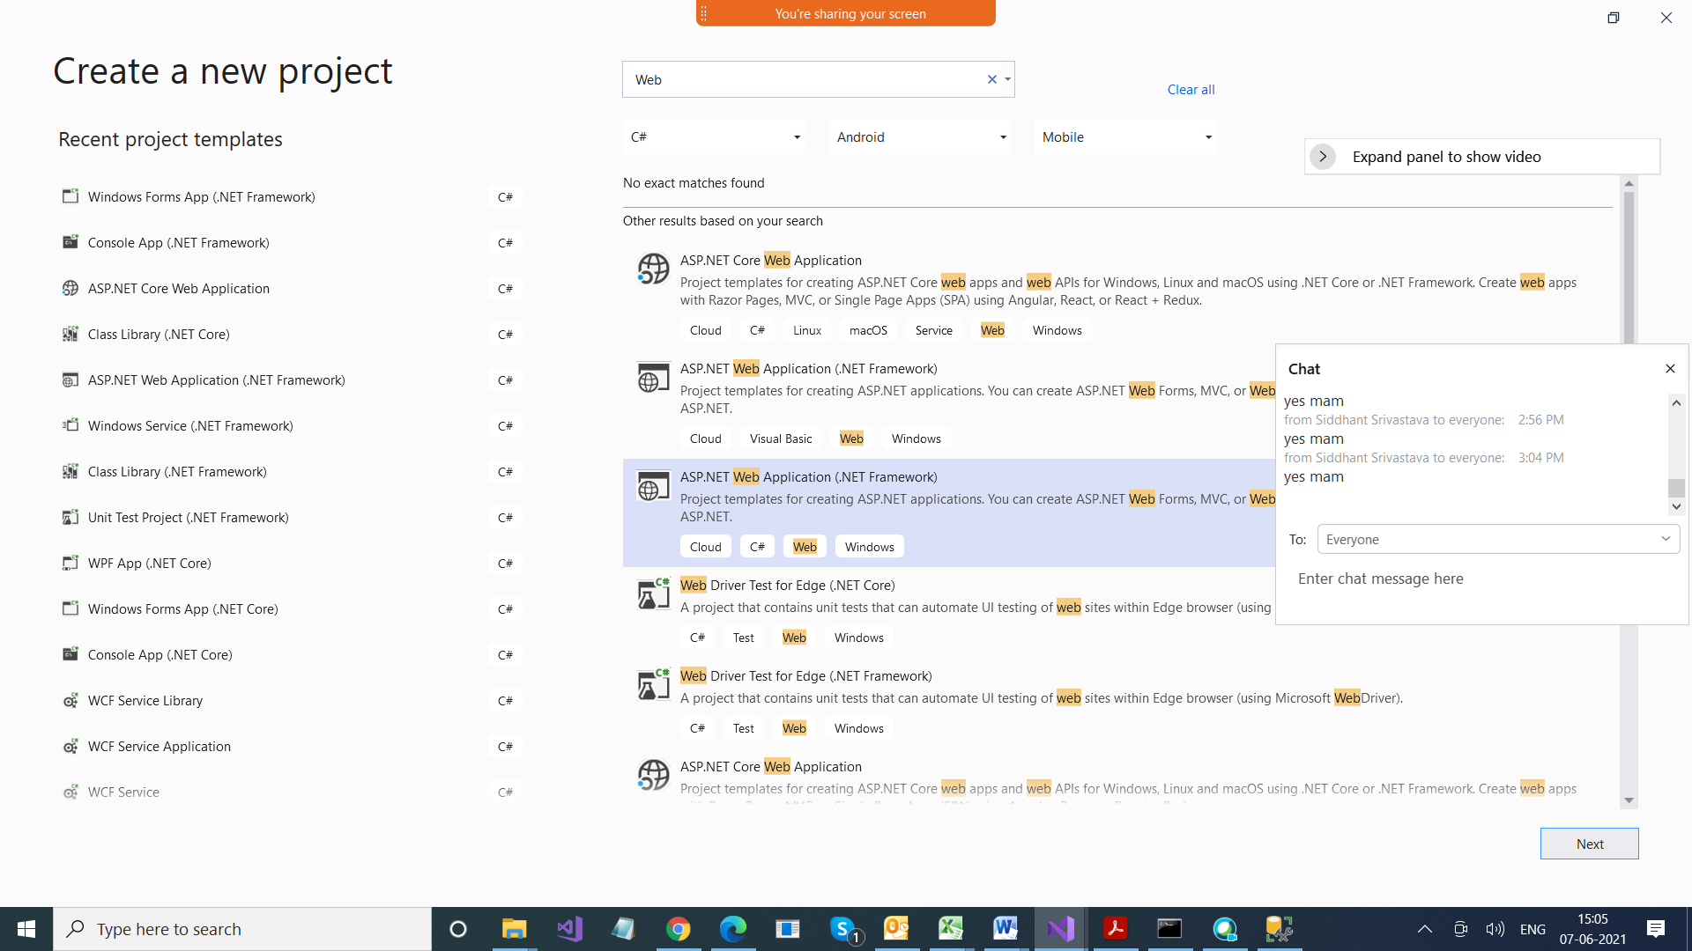

Blank Project

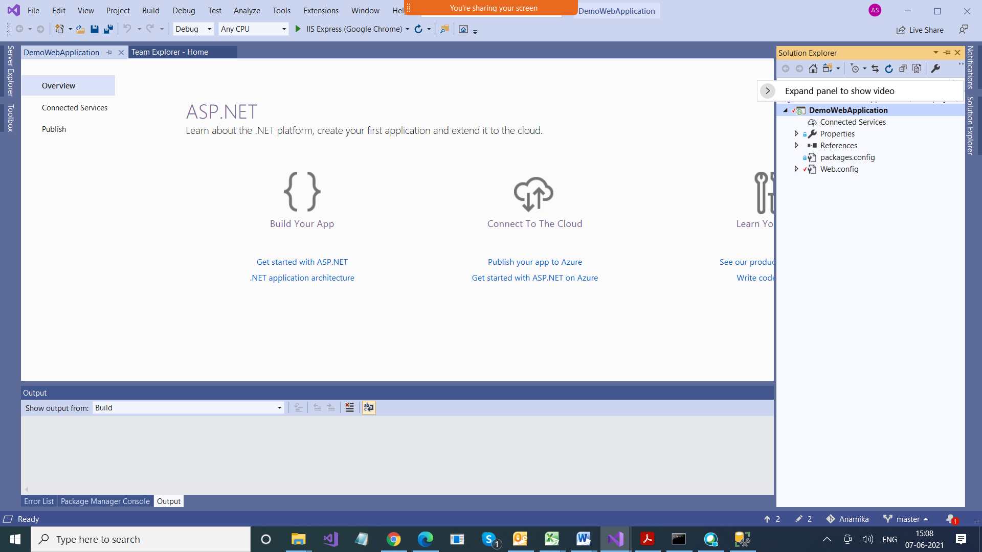

Web Forms

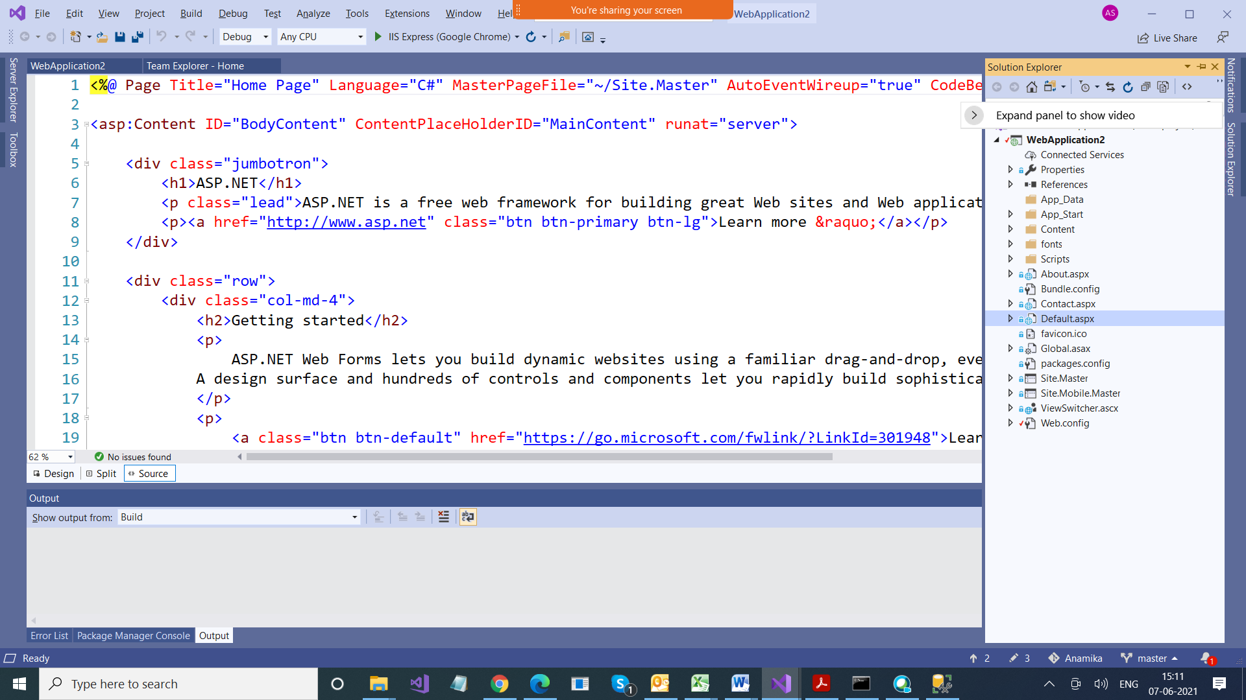

MVC

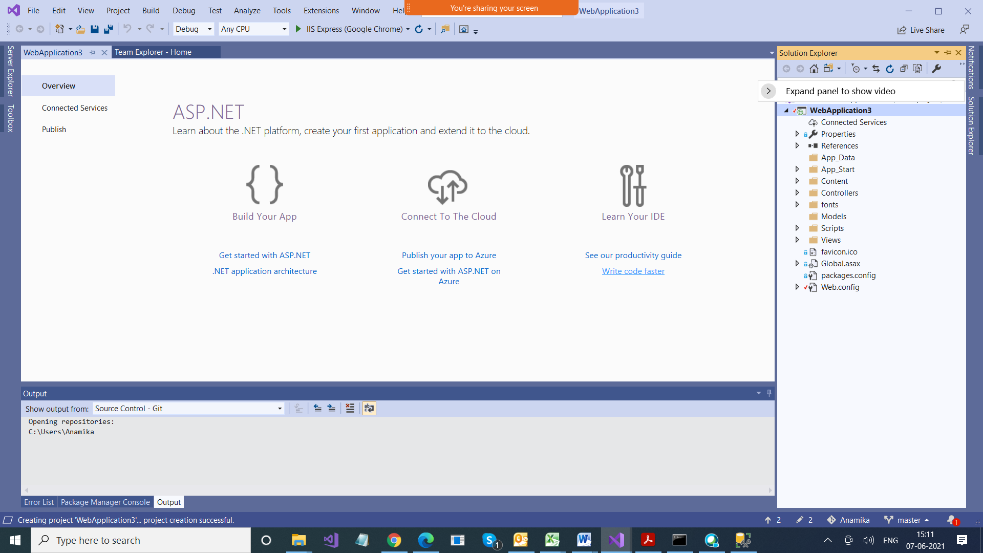

MVC > Model View Controller

Model > Represents your Data/Domain

View > html pages

Controllers > Request Handlers

<https://localhost:44307/>

Why https / http coming ?

http is protocol ? Why > Because we are talking client server, which cud be different machines too

that when we communicate between two machines,

they cud be of different confi. So t make them compatible we use some rules for communications, and those are ks protocol

Because we are running web application

Web Applications always follows client server arch

Server is what > where is application is hosted

(IISExpress is local server)

Client > browser

Localhost > server , right now our server is also on same machine (IISExpress)

